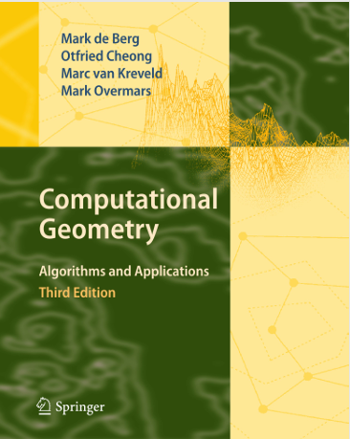
a Python implementation of the Fortune’s algorithm based on the description of “Computational Geometry: Algorithms and Applications”

Algorithm.py
Input: list of points sites
Output: Voronoi diagram “edges&vertices”
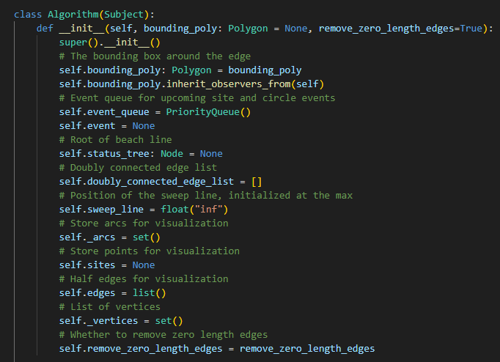
constractor has
Parameters
bounding_poly: Polygon
The bounding box around the voronoi diagram to avoid infinite edges
remove_zero_length_edges: bool
Removes zero length edges and combines vertices with the same location into one

Attributes
bounding_poly: Polygon
The bounding box (or polygon) around the edge
event_queue: PriorityQueue
Event queue for upcoming site and circle events
status_tree: Node
The status structure is a data structure that stores the relevant situation at the current position of the sweep line.
This attribute points to the root of the balanced binary search tree that functions as a
status structure which represents the beach line as a balanced binary search tree.
sweep_line: Decimal
The y-coordinate
arcs: list(:class:`foronoi.nodes.Arc`)
List of arcs
sites: list(:class:`foronoi.graph.Point`)
List of points
vertices: list(:class:`foronoi.graph.Vertex`)
List of vertices
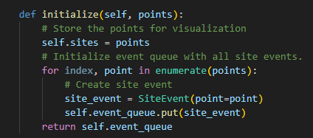
Initialize the event queue `event_queue` with all site events.
Parameters
points: list(Point)
The list of cell points to initialize
Returns
event_queue: PriorityQueue
Event queue for upcoming site and circle events
المفروض جوا ال site_event الاقي حاجة بترتب حسب ال y
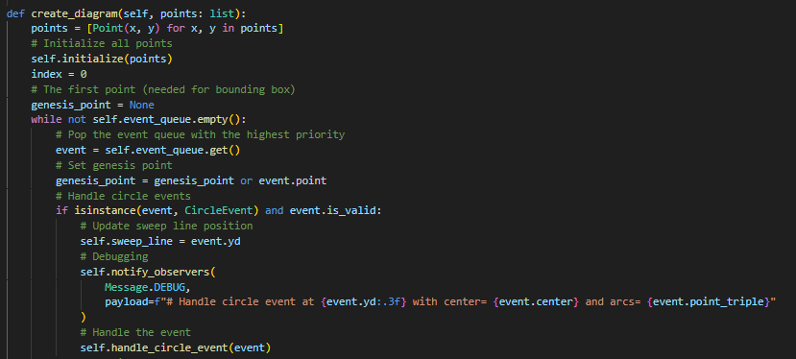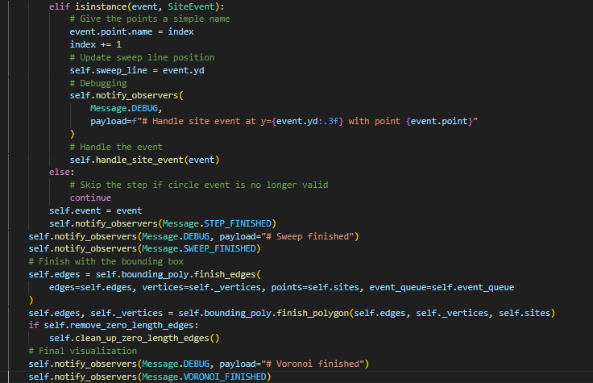
Create the Voronoi diagram.
Parameters
----------
points: list(Point)
A set of point sites in the plane.
Returns
-------
Output. The Voronoi diagram `Vor(P)` given inside a bounding box in a doublyconnected edge list `D`.

The overall structure of the algorithm is as follows.
- Initialize the event queue `event_queue` with all site events, initialize an empty status structure `status_tree` and an empty doubly-connected edge list `D`.

- while `event_queue` is not empty do
Remove the event with largest `y`-coordinate from `event_queue`.
if the event is a site event, occurring at site `point`
then : func: handle_site_event`
else : func: handle_circle_event`
- The internal nodes still present in `status_tree` correspond to the half-infinite edges of the Voronoi diagram. Compute a bounding box (or polygon) that contains all vertices of bounding box by updating the doubly-connected edge list appropriately.

- If `remove_zero_length_edges` is true.
Call :func:`~clean_up_zero_length_edges` which removes zero length edges and combines vertices with the same location into one.

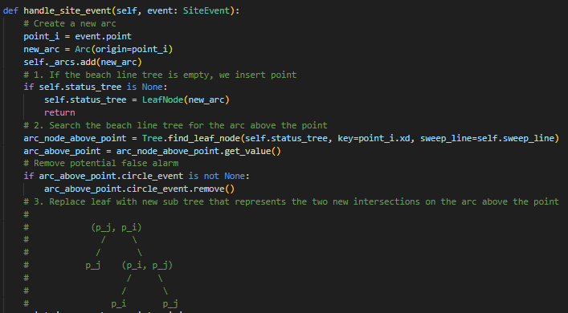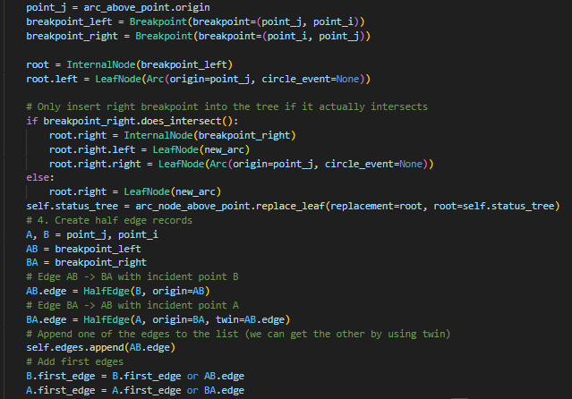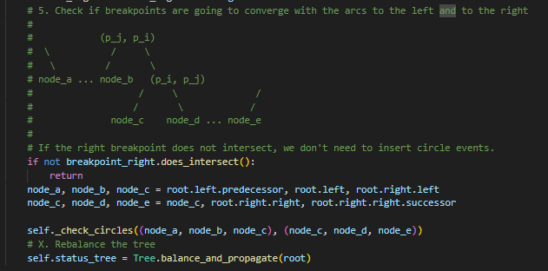
Handle a site event.

Parameters
----------
event: SiteEvent
The site event to handle.
1. Let :obj:`point_i = event.point`. If :attr:`status_tree` is empty, insert :obj:`point_i` into it (so that
:attr:`status_tree` consists of a single leaf storing :obj:`point_i`) and return. Otherwise, continue with
steps 2– 5.
• إذا الشجرة (status_tree) فاضية → نبسّط: نعمل leaf واحد يخزن النقطة الجديدة وننتهي من هذا الحدث.
2. Search in :attr:`status_tree` for the arc :obj:`α` vertically above :obj:`point_i`. If the leaf
representing :obj:`α` has a pointer to a circle event in :attr:`event_queue`, then this circle event is a
false alarm and it must be deleted from :attr:`status_tree`.
وإلا: نبحث في الشجرة عن الـ arc مباشرة فوق النقطة (الـ arc الذي يغطي ذلك الـ x عند مستوى خط المسح
- إذا ذلك الـ arc كان مرتبطًا بـ circle event سابق → هذا circle event أصبح «إنذار كاذب» (false alarm) ويجب حذفه/إلغاؤه.
3. Replace the leaf of :attr:`status_tree` that represents :obj:`α` with a subtree having three leaves.
The middle leaf stores the new site :obj:`point_i` and the other two leaves store the site
:obj:`point_j` that was originally stored with :obj:`α`. Store the breakpoints
(:obj:`point_j`, :obj:`point_i`) and (:obj:`point_i`, :obj:`point_j`) representing the new breakpoints at the
two new internal nodes. Perform rebalancing operations on :attr:`status_tree` if necessary.
4. Create new half-edge records in the Voronoi diagram structure for the
edge separating the faces for :obj:`point_i` and :obj:`point_j`, which will be traced out by the two new
breakpoints.
5. Check the triple of consecutive arcs where the new arc for pi is the left arc
to see if the breakpoints converge. If so, insert the circle event into :attr:`status_tree` and
add pointers between the node in :attr:`status_tree` and the node in :attr:`event_queue`. Do the same for the
triple where the new arc is the right arc.
الـ docstring يشرح خطوات معالجة Site Event كالتالي:
- إذا الشجرة (status_tree) فاضية → نبسّط: نعمل leaf واحد يخزن النقطة الجديدة وننتهي من هذا الحدث.
- وإلا: نبحث في الشجرة عن الـ arc مباشرة فوق النقطة (الـ arc الذي يغطي ذلك الـ x عند مستوى خط المسح).
  - إذا ذلك الـ arc كان مرتبطًا بـ circle event سابق → هذا circle event أصبح «إنذار كاذب» (false alarm) ويجب حذفه/إلغاؤه.
- نستبدل الورقة التي تمثل ذلك الـ arc بتفرّع (subtree) ثلاث أوراق بحيث الـ leaf الأوسط يخزن الـ point الجديد، واثنتان يخزنان موقع الـ point القديم (p_j). تقريبا بنخلق نقطتي تقاطع (breakpoints) جديدتين.
- ننشئ سجلات نصف-حواف (half-edges) لتمثيل الحافة بين وجهي الـ Voronoi للنقطتين (p_i وp_j). هذي الحافة سيقوم البريك بوينتان بتعقبها أثناء تقدم المسح.
- نتحقق من كل ثلاثي أقواس متتاليين (على اليسار واليمين من القوس الجديد) إذا كانوا سيتقاربون — إذا نعم نُدخل circle event مناسب في طابور الأحداث ونربطه بالشجرة (pointer) بحيث لو اتغير شيء نقدر نلغي الحدث.

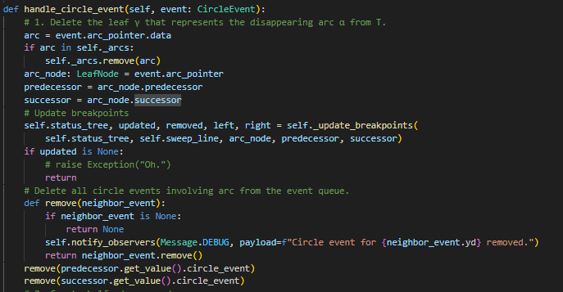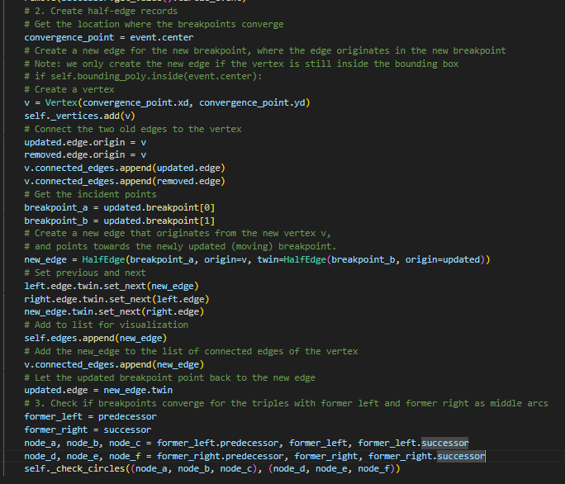
Handle a circle event.
Parameters
event
Returns
-------
1. Delete the leaf :obj:`γ` that represents the disappearing arc :obj:`α` from :attr:`status_tree`. Update
the tuples representing the breakpoints at the internal nodes. Perform
rebalancing operations on :attr:`status_tree` if necessary. Delete all circle events involving
:obj:`α` from :attr:`event_queue`; these can be found using the pointers from the predecessor and
the successor of :obj:`γ` in :attr:`status_tree`. (The circle event where :obj:`α` is the middle arc is
currently being handled, and has already been deleted from :attr:`event_queue`.)
2. Add the center of the circle causing the event as a vertex record to the
doubly-connected edge list :obj:`D` storing the Voronoi diagram under construction. Create two half-edge
records corresponding to the new breakpoint
of the beach line. Set the pointers between them appropriately. Attach the
three new records to the half-edge records that end at the vertex.
3. Check the new triple of consecutive arcs that has the former left neighbor
of :obj:`α` as its middle arc to see if the two breakpoints of the triple converge.
If so, insert the corresponding circle event into :attr:`event_queue`. and set pointers between
the new circle event in :attr:`event_queue` and the corresponding leaf of :attr:`status_tree`. Do the same
for the triple where the former right neighbor is the middle arc.
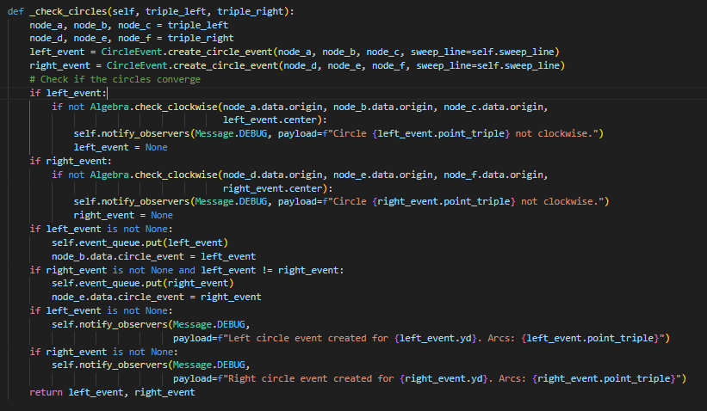
ده انا مفهمتوش
Parameters
----------
triple_left: tuple(LeafNode, LeafNode, LeafNode)
Three consecutive arcs on the left side of a disappearing or inserted arc.
triple_right: tuple(LeafNode, LeafNode, LeafNode)
Three consecutive arcs on the right side of a disappearing or inserted arc.
Returns
-------
left_event: CircleEvent or None
The circle event created from the left triple, if any.
right_event: CircleEvent or None
The circle event created from the right triple, if any.
Check for potential circle events given two triples of consecutive arcs on the beach line.

1. For each triple (left and right), attempt to create a circle event using the three arcs.
2. Verify that the circle formed by the triple has the correct clockwise orientation. If not, discard it.
3. If valid, insert the circle event into the event queue and store a pointer in the middle arc.
4. Notify observers (debugging) about any created circle events.
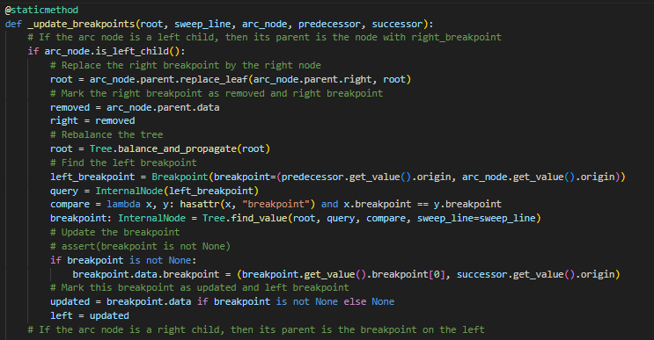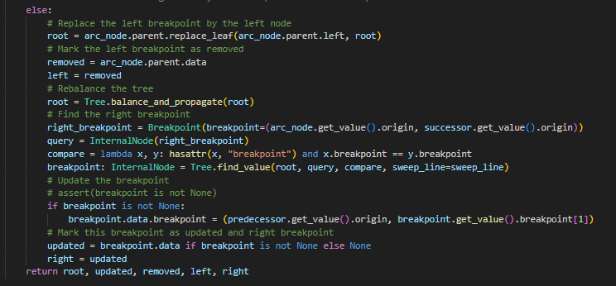
update_breakpoints
ده انا مفهمتوش
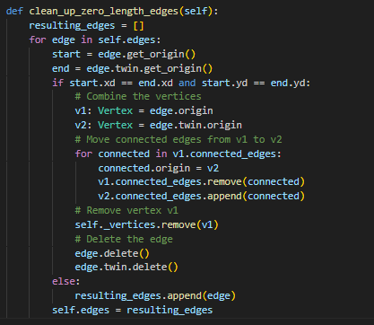
Removes zero length edges and vertices with the same coordinate
that are produced when two site-events happen at the same time.
events.py
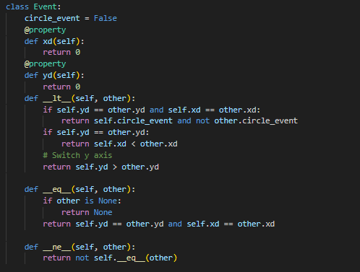

ده اللي بيرتب جوا ال event queue
بس انا مفهمتش الكود

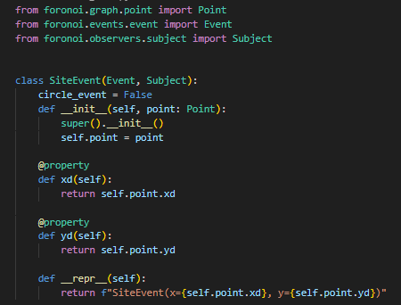
"""
A site event used in Fortune's algorithm.

A site event is generated for each input point and represents the moment
when the sweep line reaches that point. When processed, a new arc is
inserted into the beach line at the corresponding y-coordinate of the point.

Parameters
----------
point : Point
The input point that triggers this site event.
"""
"""
The x-coordinate (Decimal) of the point.
This value is used as the secondary priority when ordering events in
the event queue.

Returns
-------
Decimal
The x-coordinate of the site associated with this event.
"""
"""
The y-coordinate (Decimal) of the point.
This value is used as the primary priority when ordering events in the
event queue (events with larger y-values are processed first).
Returns
-------
Decimal
The y-coordinate of the site associated with this event.
"""
Circle_event.py
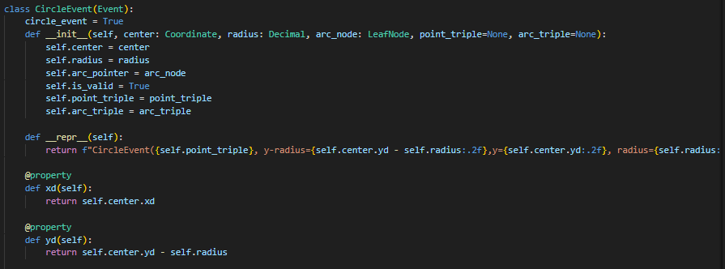
"""
A circle event.

Parameters
----------
center: Coordinate
The center coordinate of the circle (where the new vertex will appear)
radius: Decimal
The radius of the circle
arc_node: LeafNode
Pointer to the node in the beach line tree that holds the arc that will disappear
point_triple: (Point, Point, Point)
The triple of points that caused the event
arc_triple: (Arc, Arc, Arc)
The triple of arcs related to the points
"""
"""
The x-coordinate (in Decimal format) of the center of the circle, which functions as the secondary priority of this event.

Returns
-------
x: Decimal
"""
"""
The y-coordinate (in Decimal format) of the bottom of the circle, which functions as the primary priority of this event.

Returns
-------
y: Decimal
"""
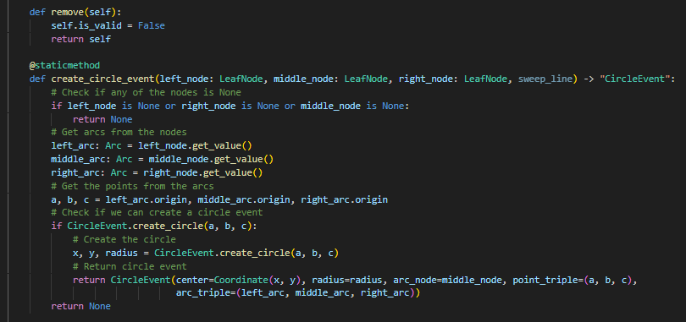
"""
Mark this circle event as a false alarm.

Returns
-------
self: CircleEvent
"""
"""
Checks if the breakpoints converge, and inserts circle event if required.

Parameters
----------
left_node: LeafNode
The node that represents the arc on the left
middle_node: LeafNode
The node that represents the arc in the middle
right_node: LeafNode
The node that represents the arc on the right
sweep_line: Decimal
The y-coordinate of the sweep line

Returns
-------
circleEvent: CircleEvent or None
The circle event or None if no circle event needs to be inserted
"""

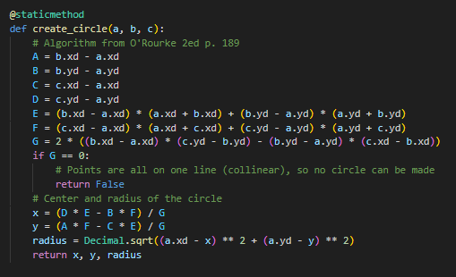
"""
Create a circle from three coordinates.

Parameters
----------
a: Coordinate
b: Coordinate
c: Coordinate

Returns
-------
x: Decimal
The x-coordinate of the center of the circle
y: Decimal
The y-coordinate of the center of the circle
radius: Decimal
The radius of the circle
"""
Arc.py
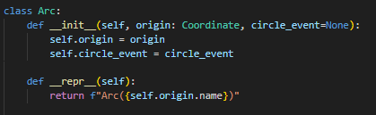
"""
Each leaf of beach line, representing an arc `α`, stores one pointer to a node in the event queue, namely, the
node that represents the circle event in which `α` will disappear. This pointer is None if no circle event
exists where `α` will disappear, or this circle event has not been detected yet.

Parameters
----------
origin: Point
The point that caused the arc
circle_event: CircleEvent
The pointer to the circle event in which the arc will disappear

Attributes
----------
origin: Point
The point that caused the arc
circle_event: CircleEvent
The pointer to the circle event in which the arc will disappear
"""
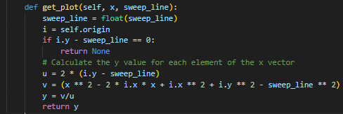
"""
Computes all `y`-coordinates for given `x`-coordinates and the sweep line's `y`-coordinate.

Parameters
----------
x: np.array
The input x-coordinates
sweep_line: Decimal, float
The y-coordinate of the sweep line
Returns
-------
y: number, array-like
A list of y-values
"""
Breackpoint.py
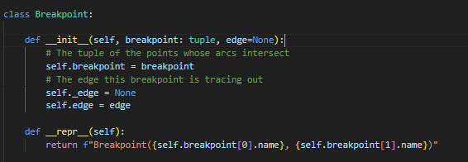
"""
A breakpoint between two arcs.
"""

"""
The breakpoint is stored by an ordered tuple of sites (:obj:`p_i`, :obj:`p_j`) where :obj:`p_i` defines the
parabola left of the breakpoint and :obj:`p_j` defines the parabola to the right. Furthermore, the internal node
:obj:`v` has a pointer to the half edge in the doubly connected edge list of the Voronoi diagram. More
precisely, :obj:`v` has a pointer to one of the half-edges of the edge being traced out by the breakpoint
represented by :obj:`v`.

Parameters
----------
breakpoint: (Point, Point)
A point where two arcs intersect, represented as a tuple of the two site points that the arcs refer to
"""
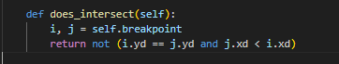
"""
A guard that handles the edge-case where two arcs were initialized at the same time due to their sites
having the same :obj:`y`-coordinate. This guard makes sure that the left arc intersects once with the right arc
and not the other way around.

Returns
-------
intersects: bool
Returns false when :obj:`p_i` and :obj:`p_j` have the same y-coordinate and :obj:`p_j` is
situated left of `p_i`.
"""
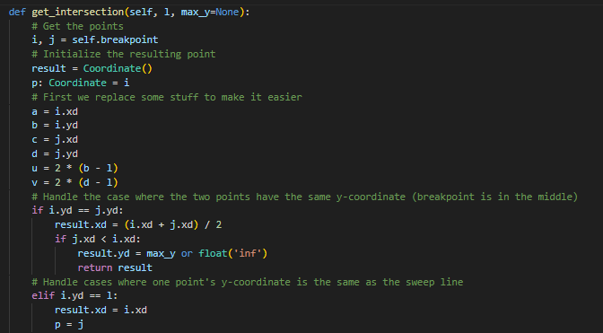
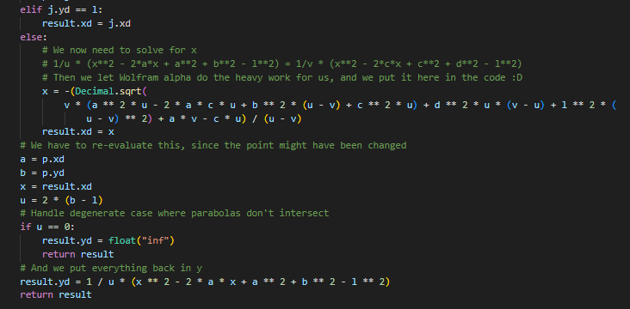

"""
Calculate the coordinates of the intersection
Modified from https://www.cs.hmc.edu/~mbrubeck/voronoi.html

Parameters
----------
l: float
The y-coordinate of the sweep line
max_y: float
The top of the bounding box/polygon for clipping infinite breakpoints

Returns
--------
coordinate: Coordinate
The current coordinates of the breakpoint
"""

Internal_node.py
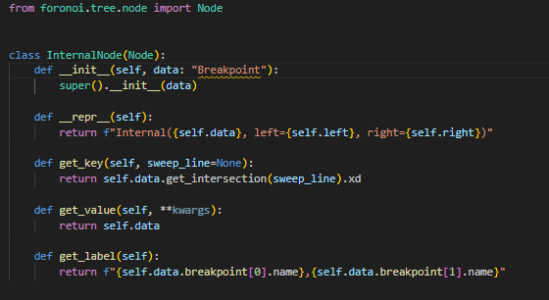
Leaf_node.py
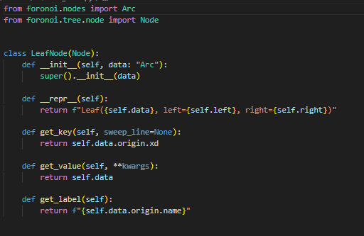

Bounding_box.py
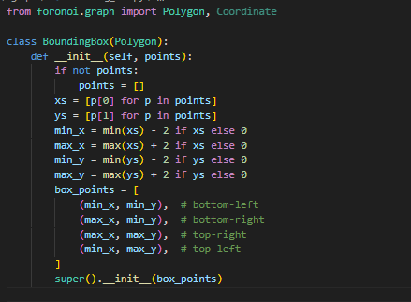

"""
Convenience class to create a bounding box around a set of points.
Extends :class:`foronoi.graph.Polygon`.
"""
"""
Parameters
----------
points: list of tuples [(x1, y1), (x2, y2), ...]
The points that will be enclosed by the bounding box.
"""
Half_edges.py
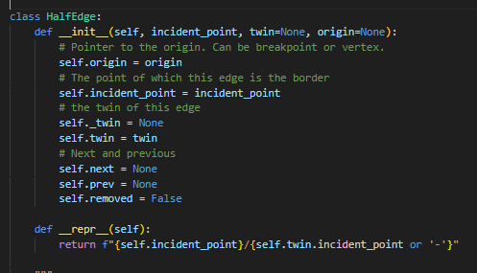
"""
Edges are normally treated as undirected and shared between faces. However, for some tasks (such as simplifying
or cleaning geometry) it is useful to view faces as each having their own edges.
You can think of this as splitting each shared undirected edge along its length into two half edges.
(Boundary edges of course will only have one "half-edge".)
Each half-edge is directed (it has a start vertex and an end vertex).

The half-edge properties let you quickly find a half-edge’s source and destination vertex, the next half-edge,
get the other half-edge from the same edge, find all half-edges sharing a given point, and other manipulations.

Examples
--------
Get the half-edge's source

>>> edge.origin

Get the half-edge's destination

>>> edge.target # or edge.twin.origin

Get the previous and next half-edge

>>> edge.prev
>>> edge.next

Get the other half-edge from the same edge

>>> edge.twin

Find all half-edges sharing a given point

>>> edge.origin.connected_edges

Parameters
----------
incident_point: Point
The cell point of which this edge is the border
twin: HalfEdge
The other half-edge from the same edge
origin: Breakpoint or Vertex
The origin of the half edge. Can be a Breakpoint or a Vertex during construction, and only Vertex when
the diagram is finished.

Attributes
----------
origin: :class:`Breakpoint` or :class:`Vertex`
Pointer to the origin. Can be breakpoint or vertex.
next: :class:`HalfEdge`
Pointer to the next edge
prev: :class:`HalfEdge`
Pointer to the previous edge
"""

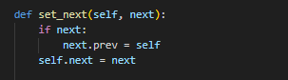
"""
Update the `next`-property for this edge and set the `prev`-property on the `next`-edge to the current edge.

Parameters
----------
next: HalfEdge
The next edge
"""
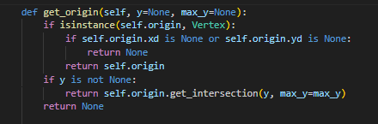
"""
Get the coordinates of the edge's origin.
During construction of the Voronoi diagram, the origin can be a vertex, which has a fixed location, or a
breakpoint, which is a breakpoint between two moving arcs. In the latter case, we need to calculate the
position based on the `y`-coordinate of the sweep line.

Parameters
----------
y: Decimal
The y-coordinate of the sweep line.
max_y:
Bounding box top for clipping infinitely highly positioned breakpoints.

Returns
-------
origin: Coordinate
"""
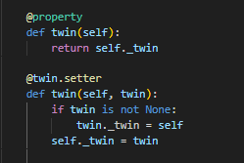

"""
Get the other half-edge from the same edge

Returns
-------
twin: HalfEdge
"""
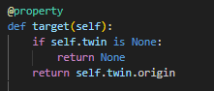
"""
The twin's origin.

Returns
-------
vertex: Vertex
"""
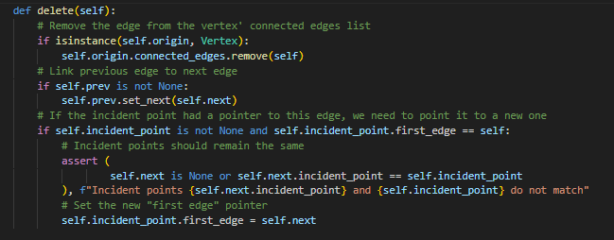
"""
Delete this half edge by pointing the previous edge to the next, and removing it from the origin's
connected edges list.
"""

Points.py
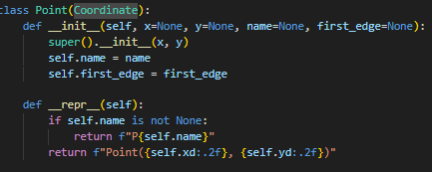

"""
A cell point a.k.a. a site. Extends the :class:`Coordinate` class.

Examples
--------
Site operations

>>> size: float = site.area() # The area of the cell
>>> borders: List[HalfEdge] = site.borders() # Borders around this cell point
>>> vertices: List[Vertex] = site.vertices() # Vertices around this cell point
>>> site_x: float = site.x # X-coordinate of the site
>>> site_xy: [float, float] = site.xy # (x, y)-coordinates of the site
>>> first_edge: HalfEdge = site.first_edge # First edge of the site's border

Parameters
----------
x: Decimal
The x-coordinate of the point
y: Decimal
They y-coordinate of the point
metadata: dict
Optional metadata stored in a dictionary
name: str
A name to easily identify this point
first_edge: HalfEdge
Pointer to the first edge

Attributes
----------
name: str
A name to easily identify this point
first_edge: HalfEdge
Pointer to the first edge
"""
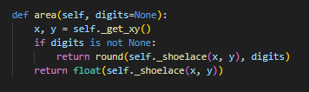

"""
Calculate the cell size of the cell that this point is the cell point of.
Under the hood, the shoelace algorithm is used.

Parameters
----------
digits: int
The number of digits to round to

Returns
-------
area: float
The area of the cell
"""
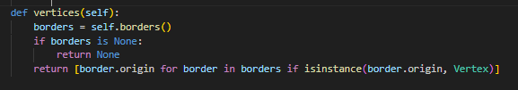
"""
Get a list of all the vertices that surround this cell point.

Returns
-------
vertices: list(Vertex) or None
The list of vertices, or None if not all borders are present (when the voronoi diagram is under
construction)
"""
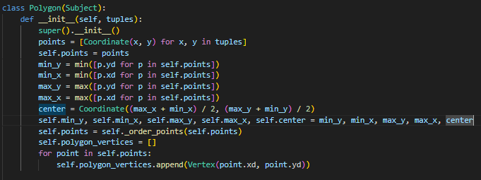
"""
A bounding polygon that will clip the edges and fit around the Voronoi diagram.

Parameters
----------
tuples: list[(float, float)]
x,y-coordinates of the polygon's vertices
"""
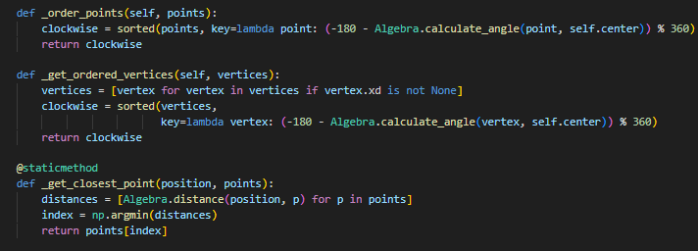
مش لاقية شرح ليهم
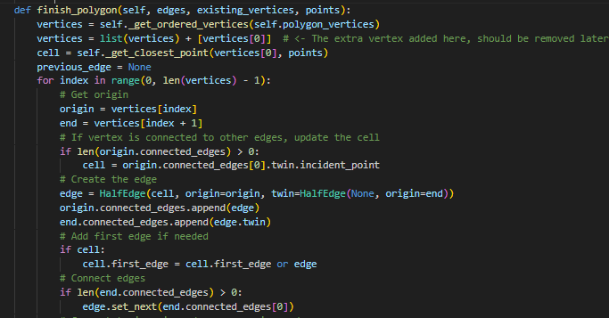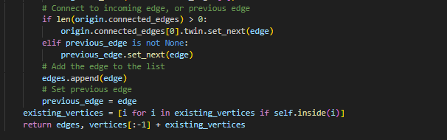
"""
Creates half-edges on the bounding polygon that link with Voronoi diagram's half-edges and existing vertices.

Parameters
----------
edges: list(HalfEdge)
The list of clipped edges from the Voronoi diagram
existing_vertices: set(Vertex)
The list of vertices that already exists in the clipped Voronoi diagram, and vertices
points: set(Point)
The list of cell points

Returns
-------
edges: list(HalfEdge)
The list of all edges including the bounding polygon's edges
vertices: list(Vertex)
The list of all vertices including the
"""
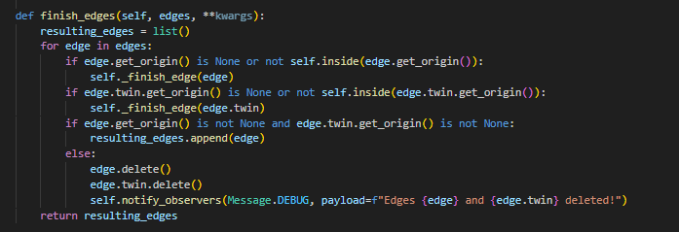
"""
Clip the edges to the bounding box/polygon, and remove edges and vertices that are fully outside.
Inserts vertices at the clipped edges' endings.

Parameters
----------
edges: list(HalfEdge)
A list of edges in the Voronoi diagram. Every edge should be presented only by one half edge.

Returns
-------
clipped_edges: list(HalfEdge)
A list of clipped edges
"""
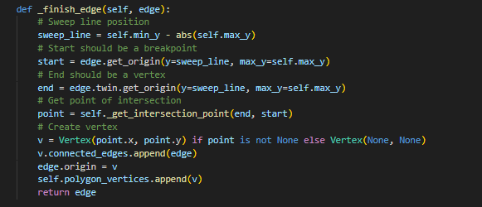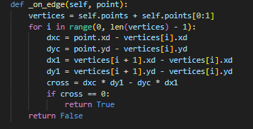
مش لاقيالهم شرح
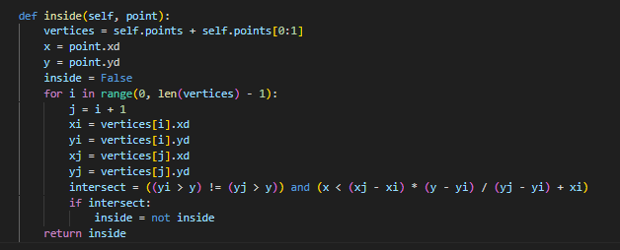
"""Tests whether a point is inside a polygon.
Based on the Javascript implementation from https://github.com/substack/point-in-polygon

Parameters
----------
point: Point
The point for which to check if it it is inside the polygon

Returns
-------
inside: bool
Whether the point is inside or not
"""

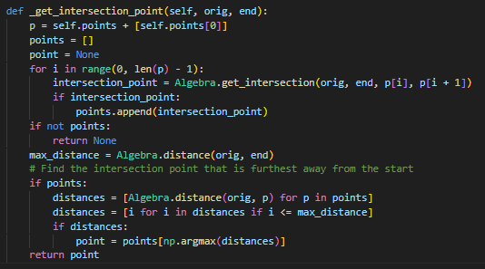
مش لاقية شرح برضو
Vertex.py
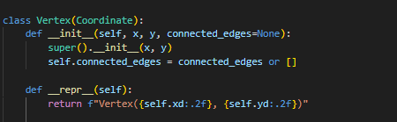
"""
A vertex is a fixed cross point between borders. Extends the :class:`Coordinate` class.

Examples
--------
Vertex operations

>>> connected_edges: List[HalfEdge] = vertex.connected_edges # All connected edges
>>> vertex_x: float = vertex.x # x-coordinate
>>> vertex_xy: [float, float] = vertex.xy # (x, y)-coordinates

Parameters
----------
x: Decimal
x-coordinate
y: Decimal
y-coordinate
connected_edges: list(:class:`HalfEdge`)
List of edges connected to this vertex.

Attributes
----------
connected_edges: list(:class:`HalfEdge`)
List of edges connected to this vertex.
"""

